PROJECT REPORT

🌾
CROP YIELD PREDICTION SYSTEM
Using a simple Machine Learning Approach

Submitted to:
VIT BHOPAL

Submitted by:
ADINATH R
(25BME10001)

Language Used:
Python

Tools / Libraries:
Python Standard Library | Matplotlib

2026

1. Abstract

Agriculture is the backbone of civilization. It is one of the important sectors in any country. This is especially true in countries like India where a large portion of the population depends on farming.

Making decisions about crop management can really impact food production. It can also increase income for farmers. This project is called Crop Yield Prediction System. It is a beginner-level Artificial Intelligence and Machine Learning application. I built it entirely in Python.

The system uses a set of historical field data. It calculates feature weights from this data. Then it applies these weights to user-entered field conditions. This helps estimate the expected crop yield.

Here's how it works. The user provides their predicted field values. Then they enter the observed values after harvest. The system computes both yields. It calculates the difference, between them. A visual bar chart is presented to make the comparison easy to understand.

The dataset used is imaginary. The algorithm is simplified. The project effectively conveys core ML principles. These include feature weighting, prediction and result comparison. All of this is done without relying on any ML library.

This report provides a walkthrough of the projects goals. It also covers the design, code, outputs, limitations and future possibilities of Crop Yield Prediction System.

2. Introduction

Predicting how much a crop will yield at the end of a season is a challenge in farming.

Farmers have to deal with rainfall, temperature changes, soil conditions and many other things that affect how well their land does.

In farming technology is being used more and more to help with these predictions and machine learning is leading this change.

This project was made as part of a course on AI and machine learning.

It shows how a simple machine learning approach can be used to make predictions.

Of using a ready-made machine learning library like scikit-learn the project builds the prediction logic from scratch using Python.

This way the inner workings of the algorithm are clear and easy to understand for someone learning about it.

The idea behind the system is simple: look at data from the field figure out how much each factor like rainfall or sunlight usually affects the yield and then use those rates to estimate future yield based on new inputs.

The user gives two sets of values: what they thought the conditions would be and what they actually were.

The system processes both. Shows how accurate the prediction was.

The result is an interactive command-line program in Python.

It outputs estimates of crop yield. Makes a bar chart using Matplotlib for visual comparison.

The program helps farmers predict how much their crops will yield.

Farmers can use this information to make decisions.

Machine learning is used to make these predictions. It helps farmers manage their land better. Crop yield prediction is important, for farmers. They can plan using these predictions.

3. Objectives

• The goal is to show that we really understand the basics of machine learning like how the computer figures out the weights from data and then uses them to make predictions.

• We want to build a system that can predict things and we want to do it all in Python without using any special machine learning tools so we can see how it all works.

• The user should be able to see how their predictions match up with what happened in the field and compare the yield.

• We will use a bar chart made with Matplotlib to show the comparison so it is easy to see at a glance.

• We will use made-up data that looks real to test the system like a real machine learning system would use field records.

• We are using programming concepts, like loops and lists and functions in a way that is similar to real life to make it more interesting.

• This project can be the starting point for an advanced tool that uses machine learning to predict crop yields in the future and that would be really useful for machine learning and, for crop prediction.

4. System Overview

The Crop Yield Prediction System is a program that you can use in the terminal. It does things one step at a time. You will not see any pictures or windows. You just read in the terminal. The Crop Yield Prediction System starts by loading some data that is already in the program. Then it figures out how important each piece of this data is. After that the Crop Yield Prediction System asks you for some information, about your fields like what you think they will produce and what they actually produced. Finally the Crop Yield Prediction System calculates the results and shows them to you.

4.1 System Flow Summary
- Load sample dataset
- Calculate weights for each feature
- Accept predicted input values from user
- Compute predicted yield
- Accept actual input values
- Compute actual yield
- Calculate difference
- Display results
- A bar chart is generated and displayed using Matplotlib.

This flow is clean and linear — no loops, no error handling.

5. Dataset Description

The information used for this project is made up, it did not come from a farm survey or a science experiment. The coder created it by hand to use as an example to show how the weight calculation and prediction logic works.

The information has five lines each line is like a report from a season. Each line has eight numbers, seven are details about the field and one is the result (how much crop was grown).

5.1 Dataset Table

Rainfall (mm) | Temp (°C) | Humidity (%) | Fertilizer (kg/ha) | Soil pH | Sunlight (hrs) | Irrigation (0-10) | Yield (tons/ha)
1000 | 41 | 60 | 58 | 8.5 | 10.4 | 9 | 4.2
2200 | 38 | 65 | 45 | 7.2 | 9.8 | 8 | 5.8
4000 | 35 | 85 | 38 | 6.2 | 8.4 | 4 | 8.9
5000 | 29 | 90 | 30 | 6.5 | 7.6 | 2 | 9.5
2800 | 38 | 75 | 49 | 7.0 | 9.0 | 7 | 6.0

5.2 Key Observations from the Data
- As rainfall increases (from 1000 mm to 5000 mm), the yield also increases — suggesting that higher moisture availability tends to support better crop growth in this sample.
- Temperature decreases as rainfall increases, which mimics real-world patterns where wetter climates tend to be cooler.
- Humidity is higher when rainfall is higher, which is consistent with how weather patterns work.
- Fertilizer usage goes down as rainfall increases, implying that water-rich environments may require less supplemental nutrition.
- Irrigation levels also drop as rainfall increases, since natural rain reduces the need for manual irrigation.
- Despite the data being imaginary, these trends reflect a degree of logical consistency that makes the predictions somewhat realistic.

Important Note: This data is not accurate or scientifically validated. It is purely for demonstration purposes within the scope of this project.

6. Input Features

The system relies on seven agricultural field parameters as inputs. These are the factors that a farmer would typically observe or measure before and during a crop season. All seven features are used both in the weight calculation phase (from historical data) and in the prediction phase (from user input).

# | Feature Name | Unit | Description
1 | Rainfall | mm | Total rainfall received during the crop season
2 | Temperature | °C | Average atmospheric temperature during the season
3 | Humidity | % | Average relative humidity level in the field
4 | Fertilizer | kg/ha | Amount of fertilizer applied per hectare of land
5 | Soil pH | Scale | pH level of the soil — affects nutrient absorption
6 | Sunlight | hrs/day | Average hours of sunlight received per day
7 | Irrigation Level | 0 to 10 | A scale indicating the level of manual irrigation applied

Each feature plays a different role in determining crop yield. In a more ML model, the relationship between these features and yield would be learned through training on thousands of real records. In this project, a simplified custom formula is used instead.

7. Methodology and Algorithm

The algorithm used in this project is a custom weight-based prediction method. It is not a standard ML algorithm like Linear Regression or Decision Tree, but it borrows the same fundamental concept: learn from historical data and use what was learned to make predictions on new data.

7.1 Weight Calculation

For each of the seven input features, the system calculates a weight. This weight tells the program: for every one unit of this feature, how much yield does it typically produce?

The formula used is:

weight[i] = (1 / N) x SUM( yield / feature[i] ) for all N records

In simple terms, for each historical record, the yield is divided by the value of that feature. This gives a rate — how much yield per unit of that feature. These rates are then averaged across all five records to get the final weight for that feature.

A total of seven weights are calculated — one per feature. They are stored in a list called weights[].

7.2 Yield Prediction Formula
Once the weights are ready, the predicted yield is calculated as follows:

raw_yield = (input[0] x weight[0]) + (input[1] x weight[1]) + ...
+ (input[6] x weight[6])

final_yield = round( raw_yield / 10 , 2 )

The division by 10 is a manual scaling step. Because the individual feature values (like rainfall in mm) are large numbers, the raw weighted sum ends up being much larger than a realistic yield value (which is typically in the range of 3 to 15 tons/ha). Dividing by 10 brings the result into a reasonable range.

The same formula is applied to both the predicted inputs and the actual inputs. The only difference is the source of the values — user's prediction vs real observed values.

7.3 Difference Calculation
After both yields are computed, the difference is calculated:
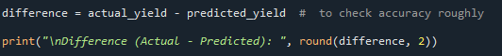

A positive difference means the actual yield was higher than predicted. A negative value means the actual yield fell short of the prediction. A value close to zero means the prediction was accurate.

8. Code Analysis

This section breaks down the Python code section by section, explaining what each part does and how it contributes to the overall system.

8.1 Library Import
import matplotlib.pyplot as plt

The only external library used is Matplotlib — specifically its pyplot module. It is used at the end of the program to generate the bar chart. Everything else in the project uses standard Python built-in functionality.

8.2 Historical Dataset

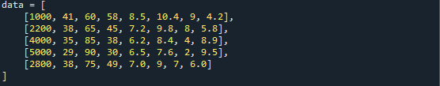
This is a 2D list (list of lists). Each inner list is one past season record with 8 values. The first seven are input features and the eighth (index 7) is the corresponding yield. This data is hard-coded into the program — there is no file reading or database connection involved.

8.3 Weight Calculation Logic
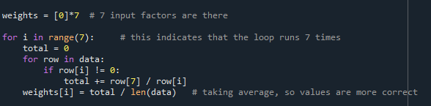
This is a nested loop. The outer loop runs seven times — once for each feature. The inner loop goes through all five historical records. For each record, it divides the yield (row[7]) by the feature value (row[i]) and adds the result to a running total. After all five records are processed, the average is calculated and stored as the weight for that feature.

The if row[i] != 0 check prevents division-by-zero errors. If a field value happens to be zero, that record is simply skipped. However, in the current dataset, no values are zero, so this check never actually triggers — but it is a good defensive programming practice.

8.4 User Input — Predicted Conditions
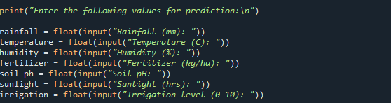
Each input() call shows a labeled prompt in the terminal and waits for the user to type a value. The float() wrapper converts the text input into a floating-point number, allowing decimal values. These seven values represent what the user expects or predicts the conditions will be.

8.5 Prediction Calculation
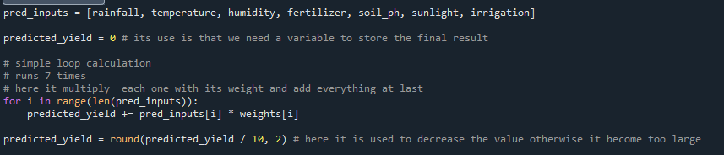
The predicted inputs are gathered into a list for cleaner code. The loop multiplies each input by its corresponding weight and accumulates the total. After the loop, the result is scaled down by dividing by 10 and rounded to 2 decimal places.

8.6 User Input — Actual Conditions
The same prompting process is repeated for the actual field conditions — what really happened during the harvest season. These values are stored in separate variables (e.g., rainfall_a, temperature_a) and collected into act_inputs[].

8.7 Actual Yield Calculation
Exactly the same formula is applied to act_inputs[] with the same weights[]. This ensures the comparison is fair — both yields are computed using the same method, so the only variable is the input data.

8.8 Difference and Output

This gives a quick numerical indication of how accurate the user's prediction was. The value is rounded to 2 decimal places for cleanliness.

8.9 Graph Generation
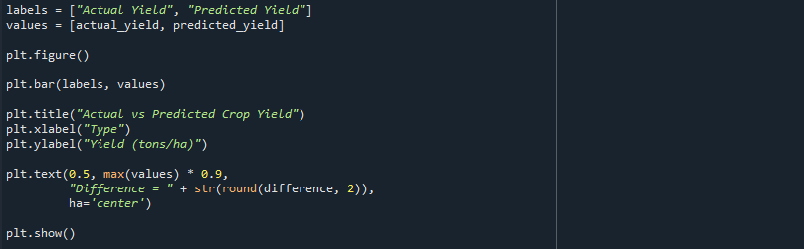
A new figure is created and a bar chart is drawn with two bars — one for the actual yield and one for the predicted yield. Axis labels and a title are added. The text() call places the difference value inside the chart near the top for quick reference. Finally, plt.show() renders and displays the chart in a pop-up window.

9. Program Output
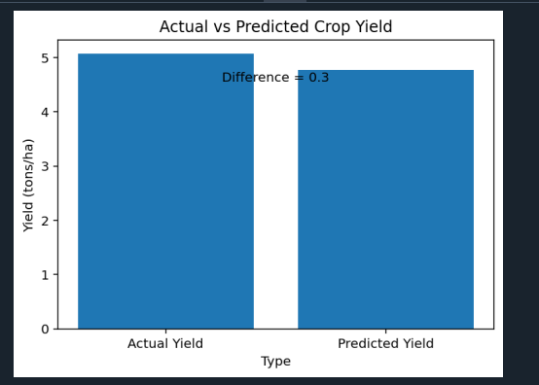
The program produces both text output in the terminal and a graphical bar chart. Below is a description of what the user sees during and after execution.

9.1 Terminal Output
When the user runs the program, they first see a prompt asking them to enter seven predicted field values. After entering all values, the system prints the predicted yield. Then it asks for seven actual values and prints the actual yield, followed by the difference.

A sample terminal session would look like this:

Enter the following values for prediction:

Rainfall (mm): 3000
Temperature (C): 34
Humidity (%): 78
Fertilizer (kg/ha): 42
Soil pH: 6.8
Sunlight (hrs): 9.0
Irrigation level (0-10): 6

Predicted Crop Yield (tons/ha): 7.43

Now enter ACTUAL field conditions:

Actual Rainfall (mm): 3200
Actual Temperature (C): 33
... (remaining inputs)

Actual Crop Yield (tons/ha): 7.89

Difference (Actual - Predicted): 0.46

9.2 Graph Output
After the terminal output, a pop-up window opens showing a bar chart titled 'Actual vs Predicted Crop Yield'. The X-axis shows the two labels (Actual Yield and Predicted Yield) and the Y-axis shows the yield in tons per hectare. The difference value is annotated inside the chart using a text label positioned near the top of the taller bar.

This graphical output makes it instantly clear how close the prediction was to reality — even a user who does not understand numbers can see immediately whether the two bars are close in height or far apart.

10. Scope of the Project

Understanding the scope of a project helps define what it is intended to do and where it is most applicable. The scope of this project is intentionally limited but well-defined.

10.1 Academic Scope
- This project is mainly for learning. It helps people understand the basic ideas of machine learning. It talks about things like how to weigh features make predictions and look at how the predictions work.
- The project is good for students who are just starting out with intelligence and machine learning or for those who have a little experience. These students want to know how predictions are made without having to learn a lot of math or use special libraries.
- The project can be used in a classroom to show people how things work or it can be the starting point for complicated projects that use machine learning concepts, like feature weighting and prediction and evaluation.

10.2 Technical Scope
- The project is a single-file Python program with no database, no web interface, and no external ML dependencies.
- It runs entirely in a terminal/command prompt and produces output both in text and via a chart window.
- It is compatible with any system that has Python 3 and Matplotlib installed.

10.3 Domain Scope
- The project is domain-specific to agriculture — crop yield estimation based on field conditions.
- With minor modifications to the dataset and input labels, the same logic could be applied to other domains like energy output prediction, sales forecasting, or student performance prediction.
- The imaginary dataset limits its use to demonstration only — it is not suitable for real farming decision-making.

11. Limitations

Every project has limitations, and acknowledging them honestly is an important part of the engineering process. This project has several limitations that should be understood before drawing any conclusions from its output.

- No real dataset used
- Assumes linear relationships only
- Ignores feature interactions
- No learning or training phase
- Sensitive to input values
- No validation or testing
- Not suitable for real-world deployment

12. Future Enhancements

This project, in its current form, is a solid starting point. With the right additions, it could grow into a genuinely useful agricultural tool. The following enhancements would significantly improve both its accuracy and usability.

12.1 Real Dataset Integration
- Replace the imaginary dataset with a real-world agricultural dataset, such as data from government agricultural research stations, NASA's POWER project (climate data), or the FAO (Food and Agriculture Organization) crop yield databases.
- Add support for reading the dataset from a CSV or Excel file using the Pandas library, so users can update the training data without modifying the source code.

12.2 Proper ML Algorithm
- Replace the custom weight formula with a proper supervised learning algorithm such as Linear Regression from scikit-learn, which would produce more statistically sound predictions.
- Explore more advanced models like Random Forest, Gradient Boosting (XGBoost), or even a simple Neural Network using TensorFlow/Keras for higher accuracy.
- Add model evaluation metrics such as Mean Absolute Error (MAE), Root Mean Squared Error (RMSE), and R-squared (R²) score to give users a quantitative sense of prediction quality.

12.3 Expanded Features
- Add crop type as an input feature so that different crops (wheat, rice, corn, cotton) can have their own prediction models.
- Include region/location as a factor, since geographical differences in climate and soil vary greatly.
- Add seasonal information (Kharif, Rabi) and year to capture temporal trends in yield data.

12.4 Improved User Interface
- Build a simple Graphical User Interface (GUI) using Tkinter or PyQt so users do not have to interact through the terminal.
- Alternatively, develop a web-based interface using Flask or Streamlit, allowing farmers to use the tool from any browser without installing Python.
- Add input validation with friendly error messages so the program does not crash on bad input.

12.5 Data Export and Logging
- Save each prediction session to a CSV or PDF file so users can maintain a record of past predictions and compare them over time.
- Build a history dashboard that shows multiple past predictions side by side for trend analysis.

12.6 Graph Improvements
- Add more chart types — such as a trend line, scatter plot of actual vs predicted values across multiple sessions, or a radar chart showing all input features.
- Apply custom colors and themes to the Matplotlib charts to make them visually cleaner and more professional.

13. Conclusion

- The Crop Yield Prediction System is a project that brings together Python programming and machine learning in a practical way. It shows how to use data to make predictions about new things. This project also checks how good these predictions are by comparing them to results.
- Building everything from scratch makes it easy to see how it works. Every step, from getting the numbers to scaling the output is written in Python. This makes it a good learning exercise for anyone trying to understand machine learning models.
- The project is not perfect. The data is small and not real, the method is easy. You can only use it in a terminal window. These limitations help create a plan for making it better. It can go from a demonstration to a real tool for predicting crop yields.
- Agriculture is important and better tools for managing crops can help with food security. Projects, like this one are part of an effort to bring technology to farms. With data, methods and interfaces this idea can help farmers make better choices.

14. References

The following references were consulted during the design and development of this project, and are recommended for anyone who wishes to learn more about the topics involved.

Tools and Libraries
- Python Software Foundation. Python 3 Documentation. https://docs.python.org/3/
- Matplotlib Development Team. Matplotlib Documentation. https://matplotlib.org/stable/contents.html

Project Repository
- Project Code and README: Available on GitHub (to be linked after upload).

